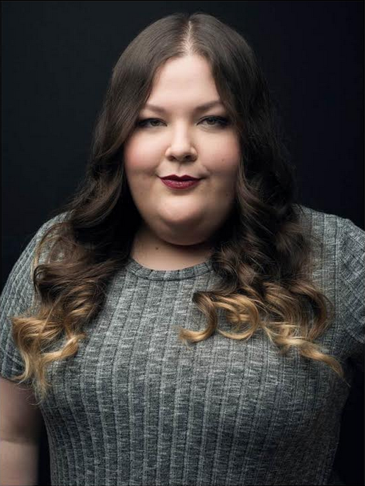
Voice: Soprano, strong belt Height: 5’7”
Eyes: Hazel
Hair: Brown
ALYSSA LECLAIR
(718) 288-1451
alyssajleclair@gmail.com
www.alyssaleclair.com

REGIONAL THEATRE
MY FAIR LADY Mrs. Eynsford-Hill Sharon Playhouse
Dir. Richard Stafford
AVENUE Q Lucy The Slut/Puppeteer 1 Blue Canoe Productions
Dir. Joey Graff
THE MARRIAGE OF FIGARO Barbarina The Hamilton Conservatory of the Arts
Dir. Roland Fix

NEW YORK THEATRE
A MAN OF NO IMPORTANCE Lily Byrne Fredrick Loewe Theatre
Dir. John Simpkins
CENDRILLON Madame Le Haltiere Fredrick Loewe Theatre
Dir. Dallet Norris
MAN OF LAMANCHA The House Keeper Skirball Centre of the Performing Arts
Dir. William Wesbrooks
CAROUSEL Nettie Fowler Fredrick Loewe Theatre
Dir. William Wesbrooks
SEE WHAT I WANNA SEE The Medium/Aunt Monica Provincetown Playhouse
Dir. MK Lawson
SOLO PERFORMANCES/CONCERTS

Blame Canada! 54 Below
Steinhardt Singers Yankee Stadium/Madison Square Garden
Dir. MK Lawson & Caleb Hoyer
Hajjar Hooligans 54 Below
Expensive Cheese: A One-Woman Spectacular (Sort of.) Pearl Company, Canadian Theatre Fest
Director, Writer & Producer
EDUCATION/TRAINING

New York University, Masters of Music – Vocal Performance, Musical Theatre
Private Voice: Dianna Heldman
Acting: Meg Bussert, William Wesbrooks, Michael Ricciardone, MK Lawson
Dance: Johnny Anzalone, MK Lawson
Coaching: Eric Kang, Ben Baker, Caleb Hoyer, MK Lawson, William Wesbrooks, Michael Ricciardone
Alexander Technique: Marcia Lesser
Queen’s University, Bachelor of Arts Honours – Theatre
Private Voice/Coaching: Sonia Reed, Marta Greta-Kicek, Tom Schilling
Acting: Chick Reid, Judy Fischer, Craig Walker, Tim Fort
Shakespeare Coach: Chick Reid
Shaw Festival Intensive
Acting: Sherry Flett, Guy Bannerman
Accents: Laurann Brown
SKILLS

Undergraduate Thesis: Puppetry/Puppeteering, Competitive Volleyball, Softball and Basketball, Accents (Available Upon Request), Painting, Overtone Singing, Beat-boxing, Weep-Riffing
